Project 1 :
We load the CSV file into the Pandas library. Pandas is a useful tool for working with data, as it allows us to easily organize, modify, and analyze it. It also provides many built-in functions for mathematical and data-related operations. In this exercise, we will explore some of these features.

Reading the CSV file
df = pd.read_csv('railway_gauges.csv')
This line reads the CSV file and stores it in a DataFrame called df.

What is a DataFrame?

A DataFrame is like a table with rows and columns.For example, your file may look like this:
Year | Broad Gauge | Metre Gauge | Narrow Gauge | Total
1964-65 | 3521 | 2891 | 464 | 6876
After reading the file, df contains the whole dataset.
Pandas reads data from a CSV file and stores it as a DataFrame object. Using this DataFrame, we can view the first 5 rows with the head() function and the last 5 rows with the tail() function. In the example above, df.head() is used to display the first 5 rows of the loaded CSV file.
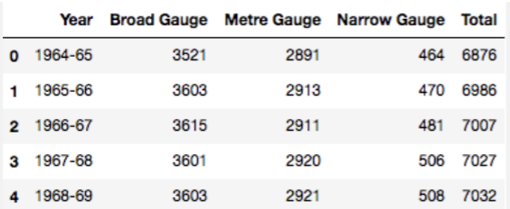

Below are some of the essential Pandas functions and attributes.
• iloc [ ] — is primarily an integer based location search — iloc[3]
• loc[] — is primarily a label based location search — loc[‘Broad
Gauge’]
• idxmax()- is a function to identify the index of first occurrence of
maximum over request axis.
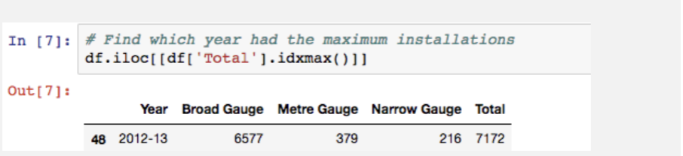

Using idxmax() function
Data Visualisation
Using Matplotlib or Seaborn, we can plot the data flow in graphical representation
format. In our example, below steps are used to see the data using bar chart.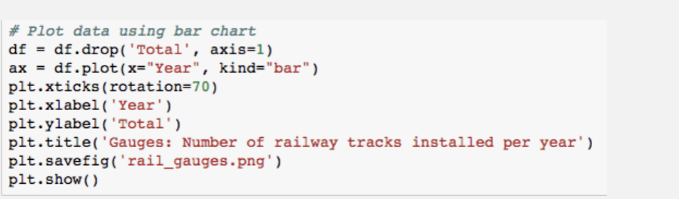

And the output graph look likes in below